**Recordings :**

> Task 1

Audio recording downloaded : [RT2161638e731247c45aecab52bb1334e2](https://www.twilio.com/console/video/logs/recordings/RT2161638e731247c45aecab52bb1334e2)

Video recording downloaded : RTbf1af0df4f565478116002b4ea43eaa2

> Task 2

Review and compare with what is posted in [https://monkey.twilio.com/accounts/{Your-Account-SID}/video/logs/rooms](https://monkey.twilio.com/accounts/%7BYour-Account-SID%7D/video/logs/rooms)

– This link gives us information about video room logs, which stores video room logs upto 7 days.

When clicked on specific room SID, it gives us information about room details, participant details

And room issues.

**Compositions :**

**Task 1**

**Create an audio-only composition.**

Audio only SID : CJ83aa76e14468d2d6cf85c9d3f57d9478

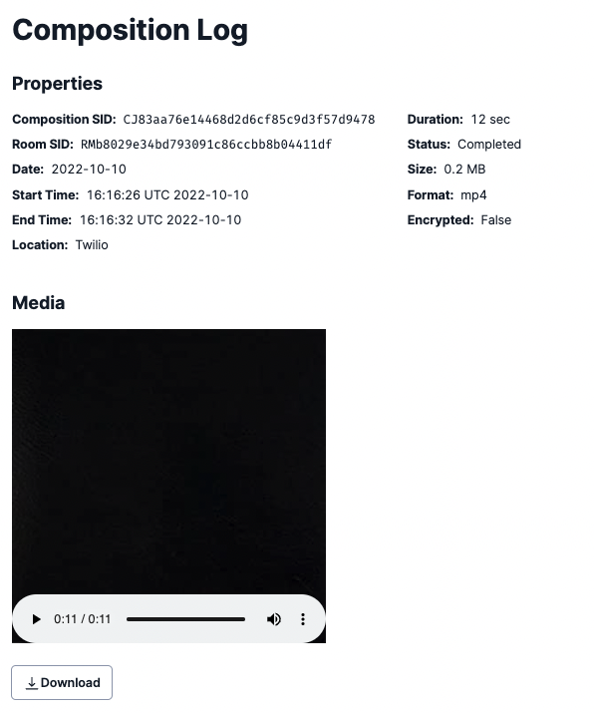

+++++++++++++++++++++++++++++++++++

**Task 2:**

**Create a video grid composition.**

Video Grid composition : CJe4a466ab0d1f79a99246478def411f8f



